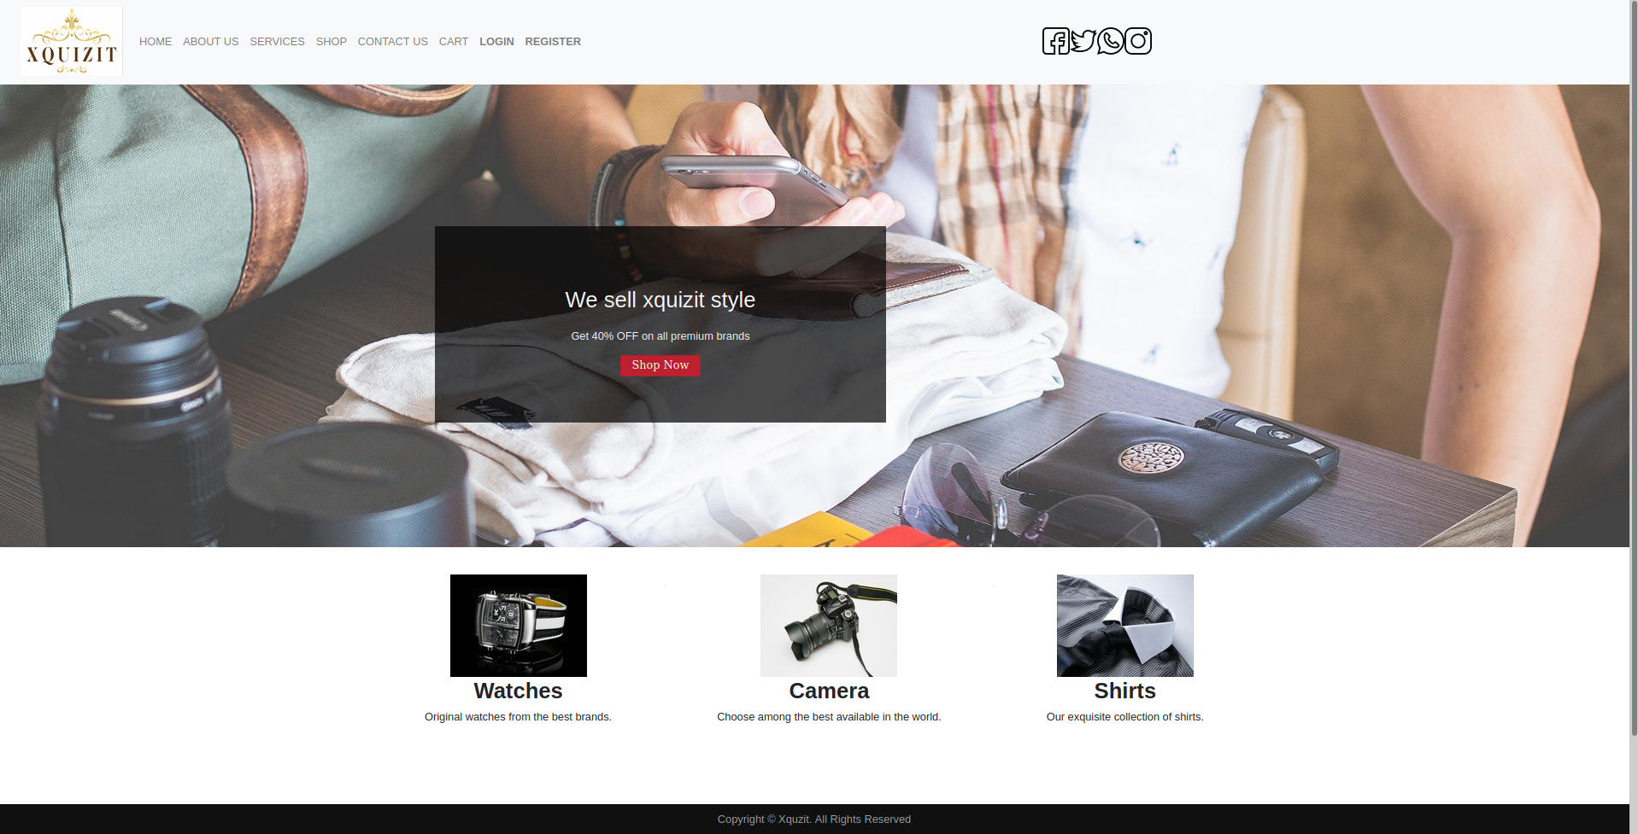
Xquizit site

Introduction to project:

An Online shopping website tamplate built with HTML, CSS, JavaScript and Bootstrap.

Detailed description:

Xquizit is an online based application template which allowes buyers to buy Xquizit items online. In order to purchase items, one needs to have a PayPal account and signned in. On checkout the buyer can pay through PayPal.

Development process:

Technology used:

- HTML.
- JavaScript.
- CSS.
- Bootstrap.
- JQuery.

